**CTSA POD Call July 1, 2025 | 12:00 PST**

**Attendees:**

Eric Vilain, UC Irvine

Dan Cooper, UC Irvine

Adrijana McFerran, UC Irvine

Vanessa Jacoby, UC San Francisco

Ron Sokol, University of Colorado

Nancy Pandhi, University of New Mexico

Carla Cordova, University of New Mexico

Ashley Kapron, University of Utah

Tong Sun, University of Washington

**Agenda and Minutes:**

1. Update from around the pod (status of NCATS awards, delays, challenges)
   1. UC Irvine – not received NOA for year 2 of UM1, under admin review; received T award NOA
   2. New Mexico – received fundable score for UM1, submitted May 2024
   3. University of Washington – received NOA 4 months late
   4. University of Colorado – yr 2 NOA, Aug 1 start day, not yet received
   5. University of Utah – back and forth process with UM1 (Yr3 was supposed to start April 1), and K/Ts (Yr3 supposed to start today). No word on R25 Yr3 (supposed to start April 1). RC2 NOA was received on time, no changes.
   6. UC San Francisco – yr 5 starts today, no response from NIH
   7. CTSA grant status: <https://uchicago.app.box.com/v/ctsas>
2. Thoughts on the RC2 versus the element E... could these be consolidated giving the hubs more leverage in identifying and supporting novel, local, science of translation endeavors
   1. ROI for pilot studies is fantastic
   2. Redistribute money from RC2s to hubs for development of translational research 🡪 there may not be that much money to redistribute
   3. Element E and pilots are useful, reallocating optional RC2 funds towards those projects could be helpful during current funding cuts
3. Implication of new NCATS grant assignment to Center for Scientific Review (CSR) (impact on Ks, Ts, CCIA, etc.)
   1. No one has heard anything, wait and see
4. Effect of planned NIH reorganization (NCATS may be a center within an institute)
   1. $394 mil budget; ~40% cut to CTSA program

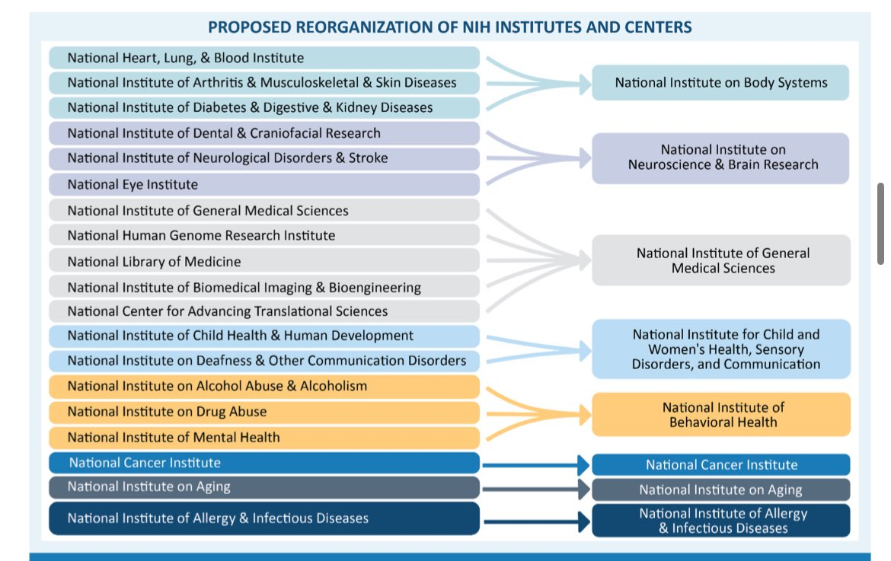

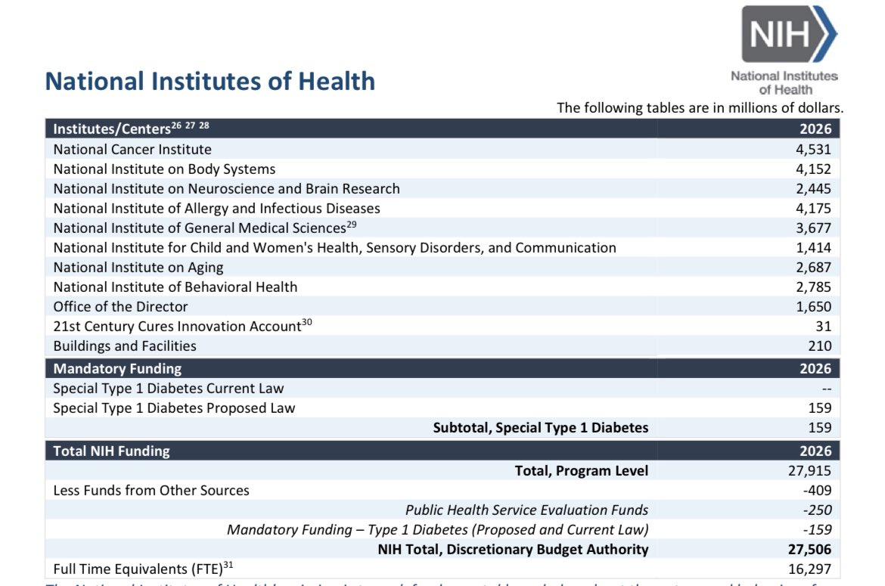

1. Insights into resolution of the indirect cost uncertainty
   1. Not discussed
2. Steps we can take to emphasize the importance of community and health disparities research
   1. Not discussed
3. Meeting concluded and will meet next month as scheduled with Dr. Kurilla joining